GREAT CHOSEN, PERFECT AND HIGHEST MASON DEGREE FOURTEEN
Translated from the Spanish Edition 2005

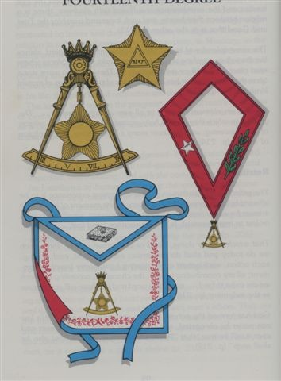
The apron is made of white sheepskin, with a crimson reverse and blue border. Around it, near the blue border is a delicate crimson embroidery representing bouquets of flowers. In the middle of the Apron the jewel is painted or embroidered, and in the Baveta there is a representation of a flat square stone to which a ring is attached, representing the entrance to the Secret Chamber of the previous Degree. Of its three colors, white, like the snowy purity of the ermine, represents justice; blue, the color of the perfectly symmetrical arch of the sky, represents the right thing; and crimson, the color of the fire that tests and purifies all things, represents
the truth.

The Collar of red carnation, worn on the neck to a certain point of the chest. On its left side an Acacia Branch is embroidered in green, symbolizing immortality. On the right embroidered in silver, a five-pointed star, with a Phoenician word in the center meaning "Perfection". The five-pointed Star, as the prototype of all stars, is representative of the Masonic Light. The five points also represent the five points of the Companion, and they remind us of the other interpretations of this number given in the Second Degree reading of the Symbolic Lodge.

The Jewel is a Compass open to a quarter of a circle, at the top of which there is a five-pointed crown. Inside the Compass there is a medal, which on one side represents the Sun, and on the other a five-pointed star, in the center of which is a Delta, and on it the name of the Deity in Phoenician characters. This jewel is made of gold and is worn suspended from the Necklace. On the segment of the circle the numerals III… V… VII… IX are engraved, at appropriate distances from each other. The compass reminds us that science, united with honor and virtue, made the Architect of the Temple the
companion of the Kings; and that men of intellect and learning, the great Kings of thought, are in this age the rulers of the world. The Sun as the source of light for our system was once worshiped as a God. The star as the prototype of the myriads of suns that shine on countless systems of worlds is an emblem of that Masonic Light seeking from which every Mason travels - the correct knowledge of Deity, and of his laws that control the Universe.

The Brothers in this degree also wear white gloves, symbolic of purity.

DUTIES: To assist, encourage and defend the Brotherhood.
Protect the oppressed and give them rest and desire.
Illuminate the people.
Serve the common good and be fruitful in good works.

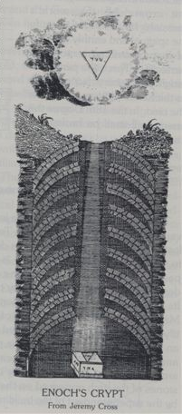
LESSONS: The Perfectly Chosen are both bound and free: bound by their obligation and free from prejudice, intolerance, and envy.
Masons are on the level because in their lives authority and freedom are in balance.

FOR REFLECTION: If perfection is not obtainable, then what is the Mason striving for?

IMPORTANT SYMBOLS: Baptism,
horizontal passageway to the cavern, the cube, the Seal of Solomon, the Columns, the triangular pedestal, the Great Candelabrum with the seven lights.

This Degree is called the Degree of Perfection because it represents the perfection or concretion of the Degrees of the Symbolic Lodge of the Scottish Rite. Mackey identifies it as having a history of France, relating it to certain groups who desired the restoration of the Stuart dynasty to the throne of England. The Degree has been rewritten to eliminate political motives, replacing those lessons with ones of a frankly more religious and philosophical character.

This Degree and the Thirteenth are very closely related. The legend associated with the Cubic Stone bearing the ineffable name of the Deity is continued here. Solomon decides to place the cubic stone in a special underground cavern used by himself, King Hiram of Tyre, and Master Hiram for private lectures. The contrast between the crypt of Enoch and that of Solomon form an important allegory of the latter and of the Thirteenth Degree.

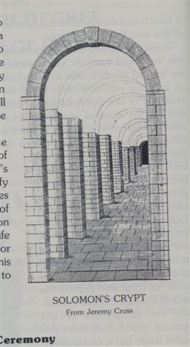
These crypts, one built by Enoch and the other built by Solomon, have two important symbolic interpretations. The first is that crypts are "symbols inward"; that is to say,
being hidden under the earth they direct our reflections toward the inner qualities of man, a reminder of the Symbolic Lodge's instruction that they are the inner, and not the external qualities recommended for a man to become a Mason. The second is that these crypts were built in a very different style and should be seen as different symbols, although united: different because each one has its own meaning and united because together they form a completely different symbol with its own interpretation. The Crypt of Enoch was built vertically. The vertical direction is symbolic of the spiritual dimension of the universe. Enoch has a prophetic vision that orders him to build his crypt and deposit the Sacred Treasure inside. Following the accomplishment of this spiritual task Enoch does not suffer the death but is taken directly to heaven (Genesis 5:24). The Enoch's crypt is discovered and the treasure stolen and taken to Solomon who now deposits it in the depths of his crypt, built horizontally between his most secluded apartment and the Sanctus Sanctorum of the Temple. The horizontal direction signifies earthly things. Solomon was not a spiritual leader; his wisdom was earthly wisdom - he was a wise and upright ruler of men, but so far. He began to worship strange gods and led most of his people to idolatry. That is why the Hebrew people were punished with their conquest and captivity in Babylon - a story that will occupy our attention for the next two Degrees.

Uniting the vertical with the horizontal creates the symbol of the cross. All the Messiahs of the world have sought to unify the spiritual and earthly qualities of man, giving a model of perfection. This is the teaching of perfection in Masonry: live this life to the fullest while preparing for the next. In Degree Eighteen this lesson will be completed.

Ceremony
The Lodge here represents the innermost Chamber of the secret cave or crypt of the Temple of King Solomon in which the True Word, lost in the legend of the Master Degree, is revealed and allowed to be spoken. The Chamber is reached by a horizontal passage with nine arches. The Arch figures prominently in this Degree. It is a symbol used in many of the advanced Rites of Masonry. Its importance is presumed to derive from a custom of operative Masons; they marked each stone in a building, which served to identify the worker who had placed and adjusted the stone. When an arch contains a keystone, it is placed in the center of the arch and holds the other stones in place, ensuring stability to the arch. The most prominent mark of the Masons operating on the stones of the arch appeared on the keystone. This mark was made by the building superintendent. The ancient Hebrews did not actually use the keystone; she is of Roman origin. Therefore it should be understood only as symbolic, meaning stability and durability.

While the passage with the nine arches is guarded by three sentries and dimly lit, the Lodge is bright and resplendent. Gold and white colors predominate in the decoration and reflect the light from the numerous sources inside the room: the pedestal lighting on which is the agate cube that bears the ineffable name, the three lights to the south that form an equilateral triangle, the five in the West that form a square with a light in the center, the seven also in the West that form a square that encloses a triangle. In the East nine lights form a triple triangle and the Great Candelabrum on the Altar of Obligation it contains seven lights, as in the Fourth Degree but arranged differently.

The Altar of Obligation is covered with a white cloth edged with gold; Engraved on it in gold, on the eastern side are the Phoenician characters for the Hebrew word meaning perfection. The Incense Table is made of white wood embellished with gold. The Table of the Bread of the Presence is made of white wood speckled with gold.
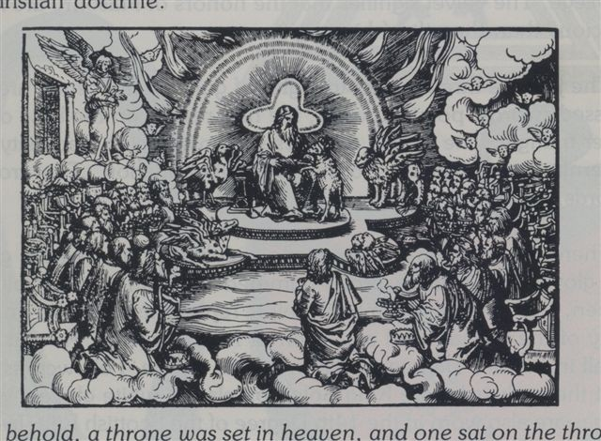
The hangings are crimson with white columns painted at intervals over them. The reading for this Degree gives us the information to understand the symbolic meaning of the Columns, "Whatever the number of the pillars (in the ancient Temples), they were mystics everywhere" (p. 235). The meaning of course, varied with the Temple and with the religious beliefs of those who had erected it. The columns could have been astrological or they could have recorded the advent of the seasons or have represented the number of days or months in a year. In all cases, however, it is significant that they were there as a testimony to the sacred character of the building. Thus, we can view its presence in the Scottish Rite Degrees as a reminder of the sacredness of the teachings of Masonry.

An important symbol here is the Seal of Solomon, made up of two interlocking triangles, one white and the other black. It was first seen in Degree Twelve. This six-pointed star can be found hidden within the Pythagorean Tetractys. Among the Greeks the Hexada (or number six) was considered a marriage symbol and the figure drawn from the six points that surround the central point of the Tetractys thus form a suitable symbol for this number as it creates six smaller equilateral triangles , the children of the union of the two largest triangles. There are deeper and more meaningful meanings to be revealed in later Degrees.

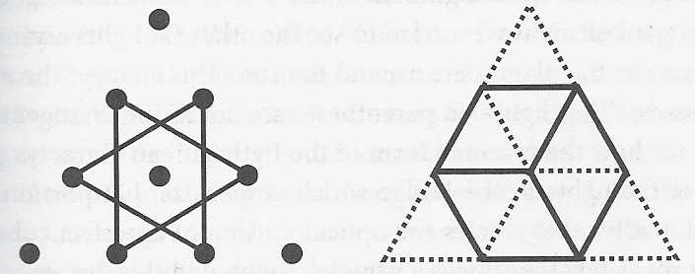
Tetractis

The cube, a profound symbol of many diverse meanings, is found first in the Thirteenth Degree as a symbol of the Scottish Rite. Of course, he is seen in the First Degree of the Symbolic Lodge where, as is appropriate, a simple interpretation is given. There the cube is called the perfect polish and is a symbol of the union between speculative and operative Masonry. As one of the so-called five Platonic Solids (which some have attributed to Pythagoras) the adoption of the cube as a mystical symbol was inevitable. It has six sides made up of perfect squares; at most only three sides are visible from any perspective and, like the Seal of Solomon, it is listed within the Tetractys as an optical illusion. These qualities combined to give the ancients numerologically inclined great opportunity for reflection and speculation.

The illuminated pedestal is triangular so that the light emanating from it can be seen as representative of the Light of Deity. It is also necessary to remember that the name of the Deity as a source of Light both figuratively and literally illuminates the Lodge. Pike tells us:

May every Great Elect, Perfect, and Sublime Mason embrace this faith. It is a must. It is the bright and perennial light that shines within and through the symbolic alabaster pedestal, on which rests the perfect agate cube, symbol of duty, inscribed with the divine name of God (p. 231).

The word reveals means “to reveal”, that is to say to give an explanation and still continue to maintain the mystery of the Symbol, not explaining it fully and completely. How this is accomplished can be illustrated by an examination of the lights of the Great Chandelier, both their number and their arrangement. On the next page there is a diagram showing how the lights are to be arranged, illustrating, says Pike, the seven planets known to the ancients: the Sun (in the center), the Moon, Mercury, Venus, Mars, Jupiter and Saturn. . That this is not the only meaning of the lights can be seen quickly, from the fact that there are no particular correspondences of the lights with the planets. The assignment of central light to the Sun is the revelation of the symbolism as we are induced to see the other six lights arranged around the central one, how are the planets around the sun. This concept was never possessed by the ancients. The “lights” enclosed in the drawing in parentheses are not part of the presentation and are added here to show the essential shape of the Pythagorean Tetractys that guides the placement of the lights in the Lodge that highlight that portion of the Pythagorean Tetractys that creates the optical illusion of a perfect cube within its limits; appropriately the cube is a main symbol of this Degree.
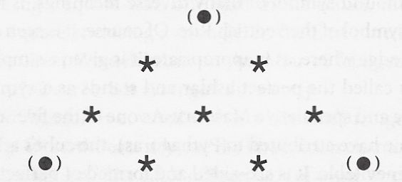

The “lights” enclosed in the drawing in parentheses are not part of the presentation and are added here to show the essential shape of the Pythagorean Tetractys that guides the placement of the lights in the Lodge that highlight that portion of the Pythagorean Tetractys that creates the optical illusion of a perfect cube within its limits; appropriately the cube is a main symbol of this Degree. The “lights” enclosed in the drawing in parentheses are not part of the presentation and are added here to show the essential shape of the Pythagorean Tetractys that guides the placement of the lights in the Lodge that highlight that portion of the Pythagorean Tetractys that creates the optical illusion of a perfect cube within its limits; appropriately the cube is a main symbol of this Degree.

The candidate again represents Yehu-Aber, as in the Eighth Degree and is symbolically aspiring to the qualities of strength and heroism through the practice of charity, benevolence, virtue, self-improvement and correction of the faults of his Brothers . He enters the dimly lit and guarded passage dressed as a Master Architect. At his reception in the brilliant splendor of the Lodge room he must assure the Brothers of their merits to receive the Degree of Perfection and consequently learn the pronunciation of the Sacred Word, joining more firmly with the Masonic Brotherhood.

Various degrees in the various rites of Masonry require the candidate to spend a short time in silence and solitude that can reflect on their character and the seriousness of the obligations they are about to assume. In this Degree the candidate is presented with research questions. He is sent to the Chamber of Reflection while the Brothers consider his aptitude to be received into the Order. Darkness is not a new condition for the Mason who has advanced to this Degree. Mackey relates, "In the Ancient Mysteries, the aspirant was always secluded in darkness as a preparatory step for receiving the full light of knowledge" (Vol. 1, p. 262). The period of darkness varied with the particular Mysteries; among the Druids it was nine days and nights, in the Greek Mysteries 27 days and among the Persians 50. The periods of darkness in Masonry have been shortened considerably and symbolize a state of readiness,

Few religious ceremonies have both the universality and the antiquity of the ritual of purification by water. Whether called "lustration," as Mackey suggests, or more commonly "baptism," this custom forms an essential part of various Degrees of the Scottish and York Rites. It should not, as is often supposed, be considered a loan from the Christian practice of baptism but rather be understood as the continuation of a ceremony much older than John the Baptist. As Pike has noted, it was practiced in ancient times by the Hindus, the Chaldeans, the Egyptians, the Etruscans, and in the main Mystical ceremonies of Greece. Some have considered the stream described in the Bible as a baptism of the whole earth. Furthermore, there are many literal and metaphorical passages in the Old Testament that allude to this practice in various forms.

Having been symbolically purified by baptism and having fulfilled the necessary conditions and requirements, the candidate is initiated Great Elect, Perfect and Sublime Mason. In an act reminiscent of the ancient Hebrew, Hindu and Persian bread and wine sacrifice, the Brethren share the bread and wine from the Table of the Bread of the Presence. Bread itself according to Mackey is a symbol of “eternal life by which we are brought into the presence of God and we know him” (Vol. 2, p. 934); Wine represents "the interior renewal of a good conscience ... and should remind us of the eternal renewals that the good must receive in the future life for their steadfast life in the fulfillment of duty in the present" (Vol. 2, p. 1110) . The ceremonial sharing of bread and wine is a symbol of the candidate's perfection,

Along with the Apron, Necklace, and Jewel, the candidate is also eligible to receive the Ring of the Fourteenth Degree. Pike attributes the origin of this gift to a similar votive given to the candidate who he passed through the Gothic Mysteries where he represented divine protection (pp. 430-431). The motif written in Latin on it translates: "Virtue has united, and death will not separate." The ring symbolizes the immutable and eternal nature of the Masonic virtues and the Brotherhood that they inspire. It is also equally correct to reflect on the ring the denotation of power or authority and affection. When Pharaoh appointed Joseph governor of all Egypt, he gave him this ring, probably a kind of token, which represented his authority that was now transferred to Joseph, or at least shared with him (see Genesis 41:42). The ring as a symbol of marriage leads one to reflect on the commitment of the Mason and the Fraternity.

Lecture

The reading of Morals and Dogma, and the instruction in the ceremony have two main purposes: one, to call for reflection on the nature of Deity and man's relationship with Her; and two, review the duties taught in all the Ineffable Degrees.

The Nature of Deity and man's relationship to It.

- The Mason does not claim dogmatic certainty, nor does he vaguely imagine that such a thing is possible.

- Concerning our feelings toward God and our conduct toward man, Masonry teaches little about what men can differ, and little about what they can disagree.

- The Man's views of God will contain only as much positive truth as the human mind is capable of receiving.

- Every man's conception of God must vary with his mental cultivation and mental powers.

- God is the great source of all life and matter.

- The Mason considers God a Moral Ruler, as well as an Original Creator.

- The Mason believes that God has organized this glorious but amazing world with a purpose and a plan.

- God created and governs this world with fixed, incorruptible and inexorable laws.
- God has a careful and primary interest in the affairs of the world and influences the thoughts and actions of men.

- God is our Father in heaven, in whose constant presence we live and act.

- Everything man sent to this world possesses some portion of God's truth and must proclaim it.

- The Perfect Chosen One will always work to elevate and glorify your motives.

- The Perfect Chosen One will not be indifferent to the destiny of his own Soul.

DUTIES

In the Fourteenth Degree the candidate recites the duties taught to him in the previous Degrees:

4º Practice silence, obedience, fidelity 5º Cultivate honesty, sincerity, good faith
6th Being jealous, trustworthy, selfless and benevolent; act as a peacemaker
7º Decide fairly and impartially; do justice to all men
8º instill benevolence and charity; fraternal sympathy for those under our I send
9th Destroy the ignorance
10º Fight against tyranny and fanaticism
11º Be sincere, truthful, trustworthy; be the advocate and champion of the rights of the people
12º Look for the truth and Right
13th Being guided and directed by honor and duty
14th be dedicated to virtue and the cause of humanity 4th Degree
4th Degree

Perhaps few of those who always worked, in the patience of secrecy and silence, to generate some political or social change, of which they felt intimately convinced that they were a great service to humanity, lived to see the changes made, or the well anticipated flowing from them (p. 230).

5th Degree

A good Mason is one who can look at death, and see his face with the same temperance with which he listens to his story (p. 219).

6th Degree

A good Mason is one who can equally despise wealth when he had it and when he did not have it,… one who can look towards the lands of another man with equanimity and pleasure, as if they were his own (pp. 219-220).

Masonry is philanthropic, because it recognizes the great truth that all men are of the same origin, have common interests, and must cooperate together for the same purpose (p. 221).

The hope of success, not the hope of reward, must be our stimulating and sustainable power. Our object, and not ourselves, must be our inspiring thought (p. 229).

7th Degree

The true Mason, sincerely holding that a supreme God created and governs this world, also believes that he governs it by means of Laws, which although wise, just and beneficial, are also unchangeable, inexorable (p. 228).

8th Degree

The true Mason… believes that his agonies and afflictions are ordered for his strengthening, elaboration and development (p. 228).

He who industriously sows and reaps is a good worker, and worthy of being hired. But he who sows what will be profited by others, by those who will know nothing and do not care about the sower, is a worker of a nobler order, and worthy of a more excellent reward (p. 231).

9th and 10th Degree

Masonry is Hercules, Osiris, Apollo, Mithra, and Hormuz always in permanent and mortal combat with the demons of ignorance, brutality, unfoundedness, falsehood, slavery of the soul, intolerance, superstition. , tyranny, emptiness, insolence of wealth, and hypocrisy (p. 221).

9th and 12th Degree

Essentially philanthropic, philosophical and progressive, Masonry is based on its dogma a firm belief in the existence of God and his providence, and in the immortality of the soul; because its objective is the dissemination of moral, political, philosophical and religious truth, and the practice of all virtues (p. 220).
11th Degree

Life is real and tough, and full of duties to fulfill. It is the beginning of our immortality. Those who have only deep affection and concern for this world will work resolutely for its betterment (p. 231).

12th Degree

… Do what is right to do, not because it will ensure your success, or it will bring you a reward, or you will win the applause of men, or it will be the “best policy”, more prudent or more advisable; if not because it is correct and therefore must be done (p. 219).

13th Degree

Honor and submit to the clear lights that will guide the ship of your life on the stormy seas of time (p. 219).

14th Degree

And such a Mason can recognize that his life is the life of a man, and will calculate his months, not by the course of the Sun, but by the zodiac and circle of his virtues (p. 220).

The perfect truth is not available anywhere. We call this degree of Perfection; and still what he teaches is imperfect and flawed. But still we must not rest in the search for truth, nor intentionally accept error. It is our duty always to advance in the search; because although the absolute truth is unattainable, even the amount of error in our points of view is susceptible to progressive and perfect diminution; and thus, Masonry is a continuous battle after the Light (p. 223).

The Mason rightly undertakes to conform to the demands of heaven and earth on his time and thought (p. 232).

Believe if you can, my Brother; If the Universe exists, for you, without a God, and if man is not like the beast that perishes, but has an immortal soul, we welcome you among us, to carry, with humility, and aware of your shortcomings and flaws, the title of Great Chosen, Perfect, and Sublime Mason (p. 233).

